A347-Eur-Crete-Knossos-Female Figurine-Faience-Poppy Headdress-1600 BCE

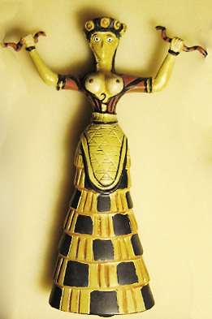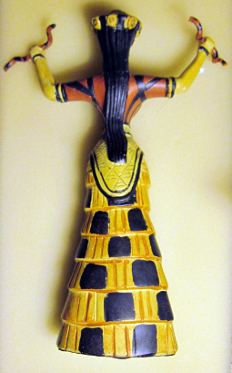

Figs. 1-2. Crete-Knossos-Female Figurine-Faience-Poppy Headdress-1600 BCE

**Case No.: 4**

**Accession Number: A347**

**Formal Label:** Crete-Knossos-Female Figurine-Faience-Poppy Headdress-1600 BCE

**Display Description:**

Knossos was the ceremonial and political center of the Minoan civilization and culture. The palace was abandoned at the end of the Late Bronze Age, c. 1380–1100 BCE which coincides with the raids of the “Sea Peoples” throughout the Mediterranean. This faïence figurine identified as a "Snake Goddess" was discovered in 1903 by Sir Arthur Evans in the so-called Temple Repositories on the site of the "palace" of Knossos. Most of the faïence pieces were found in the Eastern Repository. Ths headdress is embellished with poppies suggesting that a hallucinogenic libation accompanied the rites to this goddess..

**LC Classification** DF221.C8

**Date or Time Horizon:** 1350-1200 BCE

**Geographical Area:** Temple Repositories on the site of the "palace" of Knossos, Crete

**Map**

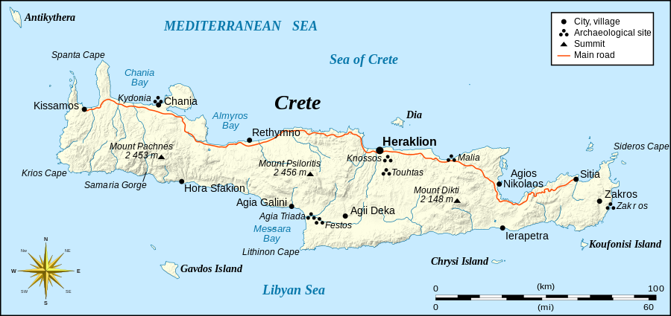

Eric Gaba ([Sting](https://commons.wikimedia.org/wiki/User:Sting)) - Own work, based on [Image:Crete_topographic_map-fr.svg](https://commons.wikimedia.org/wiki/File:Crete_topographic_map-fr.svg) (modified and translated) created by myself ; Compass rose : [Image:Brújula.svg](https://commons.wikimedia.org/wiki/File:Br%C3%BAjula.svg) (modified) created by [Serg!o](https://commons.wikimedia.org/wiki/User:Serg%21o) under GFDL

**GPS Coordinates:** 35°17'31.59" N 25°09'28.41" E

**Cultural Affiliation:** Minoan

**Geographical Area: Knossos, Crete**

**Medium:** Faience

**Dimensions**: n/a  
**Weight: n/a**

**Provenance:** (Archaeological Museum, Herakleion)

**Condition:** replica

**Discussion:**

Part of one of the figurines was found in the Western Repository, which indicated to Evans that the contents of the Eastern depository had been considerably disturbed at some period, probably by plunderers at the time of the destruction of the "palace" by an earthquake around 1600 BCE. Evans' implies that the faïence objects were broken at this time and most of the fragments swept into the Eastern Repository when the palace was rebuilt. Though the figurines must have been in existence before then, they are usually dated to the time of their destruction, around 1600 BCE.

**References:**

Evans, Arthur. 1902-03. "The Palace of Knossos," Annual of the British School in Athens, 9:1-153.

Evans, Arthur. 1921-1935. The Palace of Minos, 4 vols. London: Macmillan.

Gesell. Geraldine Cornelia. 1985. Town, Palace, and House Cult in Minoan Crete, Göteborg: Paul Åstroms Förlag.